Chapter 17: Testing Hypotheses about Proportions

**DMV Example:**

1. Open a new excel sheet.
2. Use **NORM.S.DIST** function to calculate the p-value.



where **z** is the Z score (test statistic). If “cumulative” = TRUE, the area under the curve to the left of “X” is returned. If “cumulative” = False, the height of the curve at “X” is returned.

1. Using the textbook example: sample size (n) = 90, number of who passed = 61.

|  |  |
| --- | --- |
| Sample Size (n) | = 90 (given) |
| Number of the events | = 61 (given) |
| Sample Proportion (p) |  |
| Hypothesized Value ($P_{0}$) | = 0.8 (given) |
| $$q_{0}=1-P_{0}$$ |  |
| $n*P_{0}$ condition |  |
| $n*q_{0}$ condition |  |
| SD (p) |  |
| Z score |  |
| P-value |  |

1. The result is

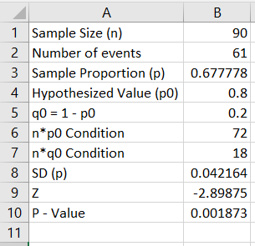

**Note:**

1. If $H_{a}:P<P_{0}$, then use P-value = NORM.S.DIST (z, True)
2. If $H_{a}:P>P_{0}$, then use P-value = 1 - NORM.S.DIST (z, True)
3. If $H_{a}:P≠P_{0}$, then use P-value = 2 (1 - NORM.S.DIST (ABS(z), True))

**Note:** **ABS** function returns the absolute value of a number.